Assignment 7:
Two instances in consideration
First – Jenkins master
Second – Slave 1
Task – create a war and deploy using the slave only. Nothing on Master
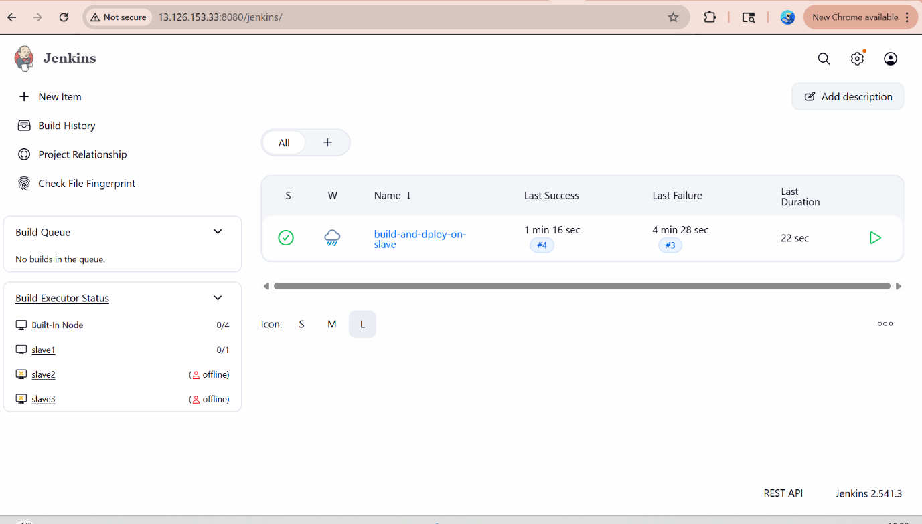
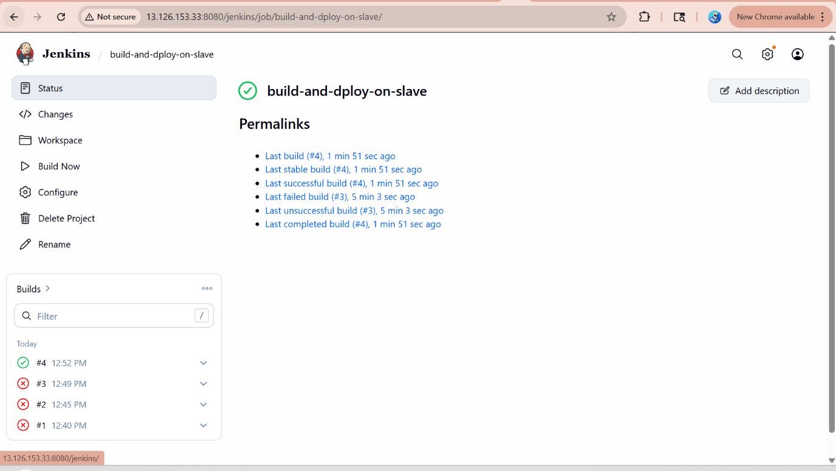
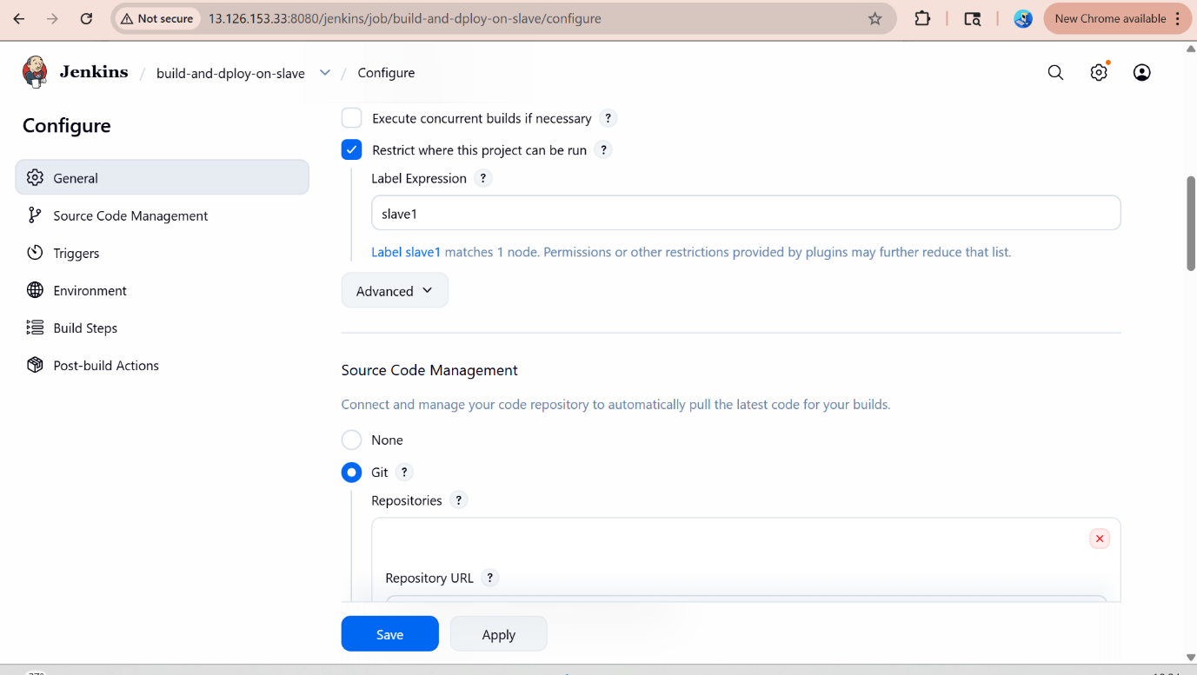

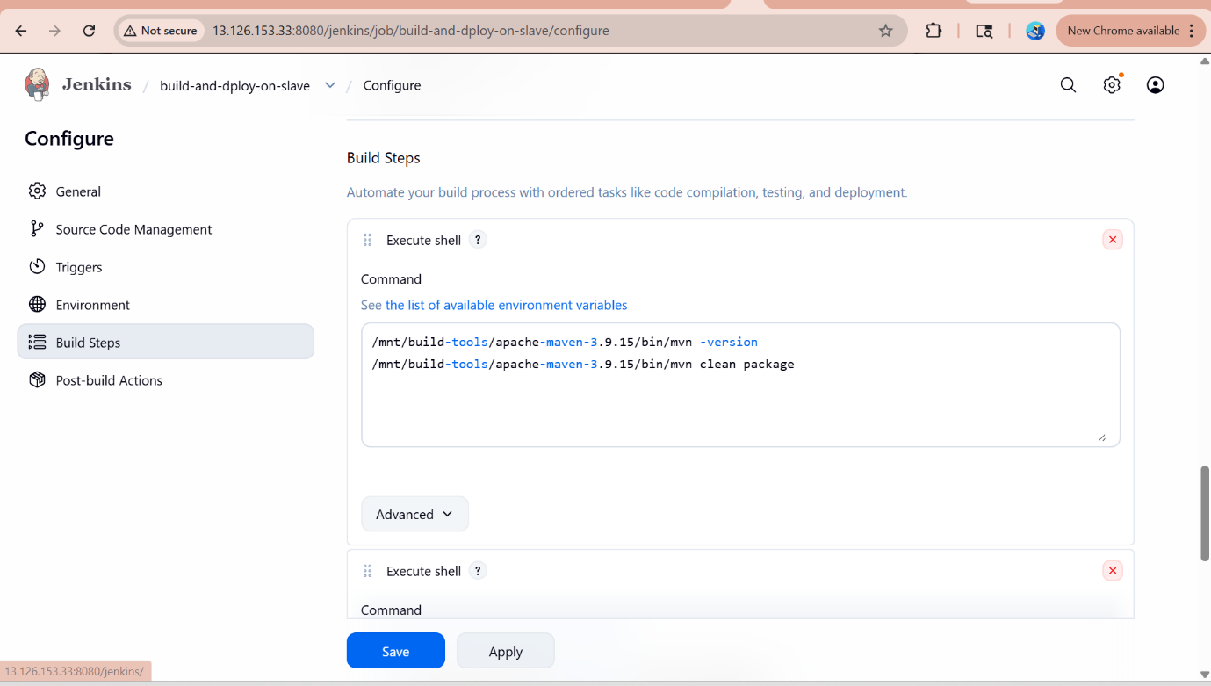

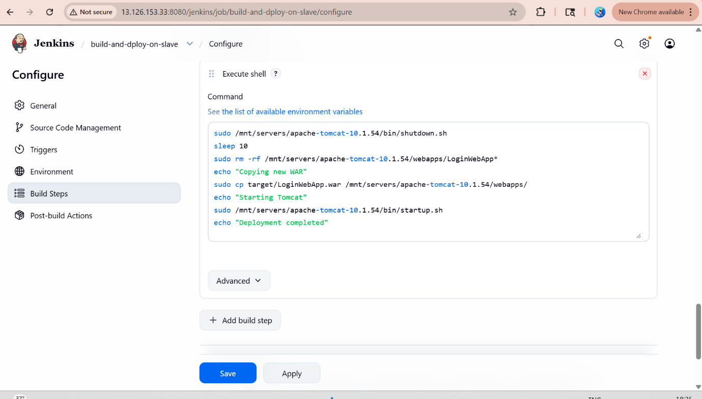
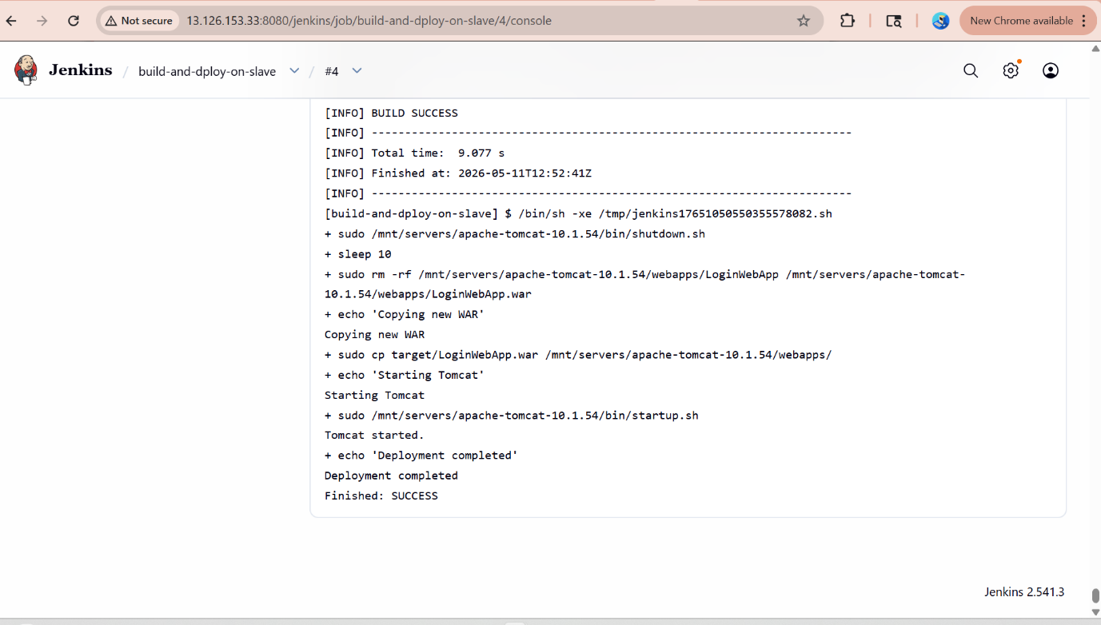
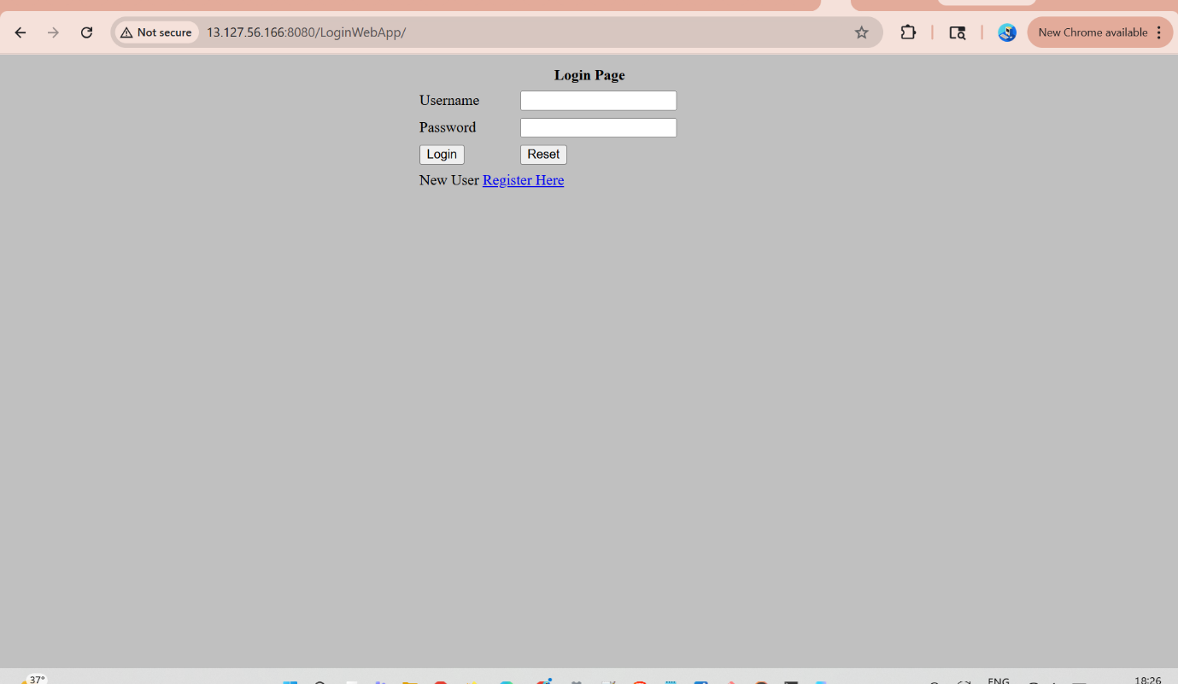
History of slave1
1 yum list java-17*
2 yum install java-17-amazon-corretto.x86_64 -y
3 yum install apache httpd -y
4 yum install httpd -y
5 cd /mnt
6 mkdir slave1-home
7 cd slave1-home/
8 pwd
9 systemctl httpd start
10 systemctl start httpd
11 yum install git -y
12 yum install aws-cli
13 cd /mnt
14 ls -ltr
15 mkdir servers
16 cd servers/
17 wget https://dlcdn.apache.org/tomcat/tomcat-10/v10.1.54/bin/apache-tomcat-10.1.54.zip
18 unzip apache-tomcat-10.1.54.zip
19 rm -rf apache-tomcat-10.1.54.zip
20 chmod -R 777 apache-tomcat-10.1.54/
21 cd
22 aws s3 ls
23 cd /mnt/slave1-home/
24 cd ..
25 chmod -R 777 /mnt
26 ls -ltr
27 cd /mnt
28 ls -ltr
29 git clone https://github.com/manishmanikrao7/repo1.git
30 ls -ltr
31 cd repo1/
32 ls -ltr
33 vi index.html
34 cd /var/www/html
35 cd ..
36 chmod -R 777 html
37 ls -lr
38 history
39 cd /mnt/servers/apache-tomcat-10.1.54/l
40 cd /mnt/servers/apache-tomcat-10.1.54/
41 ls 0ltr
42 ls -ltr
43 cd logs
44 ls -ltr
45 tail -100f catalina.out
46 cd /mnt
47 ls -ltr
48 git --version
49 git clone https://github.com/Shantanumajan6/project.git
50 ls -ltr
51 mkdir build-tools
52 cd build-tools/
53 wget https://dlcdn.apache.org/maven/maven-3/3.9.15/binaries/apache-maven-3.9.15-bin.zip
54 unzip apache-maven-3.9.15-bin.zip
55 ls -ltr
56 rm -rf
57 ls -ltr
58 rm -rf apache-maven-3.9.15-bin.zip
59 cd
60 cd /mnt/servers/apache-tomcat-10.1.54/bin/
61 ./startup.sh
62 logout
63 mvn
64 which mvn
65 ls -ltr
66 cd /mnt/build-tools/
67 ls -ltr
68 cd apache-maven-3.9.15/
69 ls -ltr
70 which mvn
71 history

